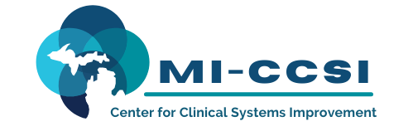
CM Leader Collaboration/Workgroup
May 7, 2025
Masonic Center at 233 E. Fulton Suite 20
11:30 noon -12:30 p.m.
Members: CMCMH, Trinity Health GR and Muskegon, Answer Health, BCBSM, Northern Michigan Care Partners, GLMG, MPCA, Corewell Lakeland, Metro Integrated Health Network
Mi-CCSI: Tom Dahlborg, Sue Vos, Amy Wales, Lynn Klima
Guest: Priority Health Jordyn Michalec

ITEM | TIME | TOOLS/METHODS | OUTCOMES | RESP
- Welcome | 10 min | Group Sharing | Learning from one another | All
- Priority Health  Guest | 25 min | Review 2026 CM initiatives  - Q and A | Informed | All
- MICCSI LMS Process | 10 min | Review new process for registration – MICMT  - Safety net to ensure compliance with MICMT requirement  - Address session challenge | Informed | All
New Trainings | 10 min | Review new training  - ASAM  - Med Rec/Review  - HEEL Videos | Informed
- Wrap-up | 5  min | Questions, comments, input | Identify actions and next steps | All

Sue Vos BSN RN CCM
CM Leadership Collaboration 2025 Goals
- Continue open forum of inquiring and sharing with one another
- Identify new issues related to CM. Gain insight and options to problem-solve
- Review incentive plans with payers

