**Michigan Center for Clinical Systems Improvement**

**233 E. Fulton Street, Suite 20**

**Grand Rapids, MI 49503**

**CERTIFICATE OF PARTICIPATION**

This certifies that:

(Name of Participant)

**Is awarded 8.0 contact hours for the educational activity entitled:**

**CoCM SUD**

(Title of CME Activity)

**July 24, 2023 & July 25, 2023** **(Live Virtual) Grand Rapids, Michigan**

(Circle Date of Activity) (City/State of Activity)

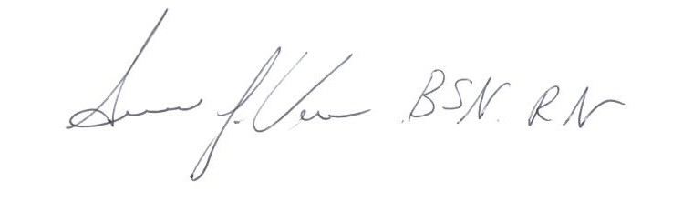This nursing continuing professional development activity was approved by the Wisconsin Nurses Association, an accredited approver by the American Nurses Credentialing Center’s Commission on Accreditation.

Susan Vos, RN, BSN, CCM

Signature of Planning Committee Activity Director

Please contact Sue Vos, Program Director at: [sue.vos@miccsi.org](mailto:sue.vos@miccsi.org) for questions about this certificate.