Michigan Center for Clinical Systems Improvement
233 E. Fulton Street, Suite 20
Grand Rapids, MI 49503

CERTIFICATE OF PARTICIPATION

This certifies that:
Enter Name of Participant

(Name of Participant)

Is awarded contact hours for the educational activity entitled:

Diabetes Management Part 1
(Title of Activity)

Enter Date Completed (Virtual) Grand Rapids, Michigan

(Date of Activity) (City/State of Activity)

This nursing continuing professional development activity was approved by the Ohio Nurses Association, an accredited approver by the American Nurses Credentialing Center’s Commission on Accreditation (OBN-001-91)
ONA Course Approval Number: 2022-0000000392
1.0 Contact Hours

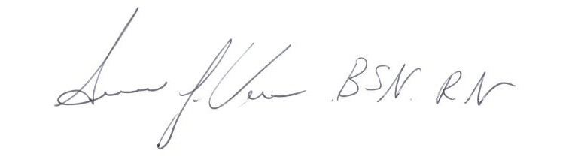

_____________________________________
Signature of Planning Committee Activity Director

