Michigan Center for Clinical Systems Improvement
233 E. Fulton Street, Suite 20
Grand Rapids, MI 49503

CERTIFICATE OF PARTICIPATION

This certifies that:
Enter Name of Participant

(Name of Participant)

Is awarded contact hours for the educational activity entitled:

SBIRT Training and Implementation
(Session #6 for BHCMs)
(Title of Activity)

May 01, 2023 (Virtual) Grand Rapids, Michigan

(Date of Activity) (City/State of Activity)

This course, Palliative Care Training is approved by the NASW-Michigan Social Work Continuing Education Collaborative.
Course Approval Number: 030123-01
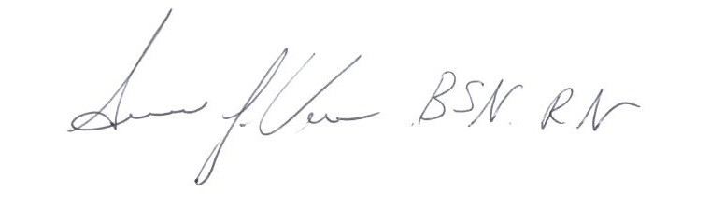
3.0 Contact Hours

_____________________________________ Signature of Planning Committee Activity Director

