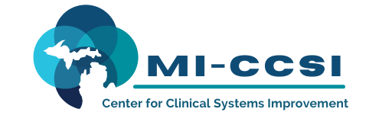

Michigan Center for Clinical Systems Improvement
233 E. Fulton Street, Suite 20
Grand Rapids, MI 49503

CERTIFICATE OF PARTICIPATION

This certifies that:
Click to Enter Name of Participant

(Name of Participant)

has participated in the educational activity entitled:

Treating Pain and Addiction Training
(Title of CME Activity)

April 28, 2023 (Virtual) Grand Rapids, Michigan

(Date of Activity) (City/State of Activity)

and is awarded up to 2.5 credits.

The AAFP has reviewed Aspects of Pain Management and deemed it acceptable for AAFP credit. Term of approval is from 12/15/2022 to 12/14/2023. Physicians should claim only the credit commensurate with the extent of their participation in the activity.
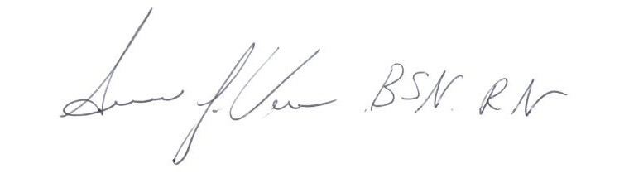
Participant’s Attestation:
- I participated in <Click or tap to enter # of credits claimed> credits of the CME activity.
Susan Vos, RN, BSN, CCM
- <Click or tap to enter text or signature & date> Activity Director-Mi-CCSI
Participant’s Signature & Signature Date
01/27/2023 Date

