Michigan Center for Clinical Systems Improvement
233 E. Fulton Street, Suite 20
Grand Rapids, MI 49503

CERTIFICATE OF PARTICIPATION

This certifies that:
Click to Enter Name of Participant

(Name of Participant)

has participated in the educational activity entitled:

Introduction to SBIRT
(Screening, Brief Intervention, Referral to Treatment for AUD/SUD)
(Title of CME Activity)

Click to Enter the Training Date (Virtual) Grand Rapids, Michigan

(Date of Activity) (City/State of Activity)

and is awarded up to 1.5 credits.

The AAFP has reviewed Palliative Care Training and deemed it acceptable for AAFP credit. Term of approval is from 03/16/2023 to 03/16/2023. Physicians should claim only the credit commensurate with the extent of their participation in the activity.
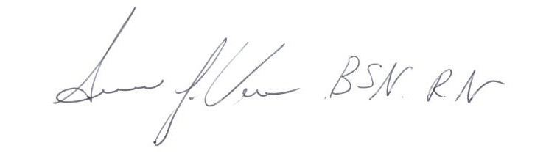
Participant’s Attestation:
- I participated in <Click or tap to enter # of credits claimed> credits of the CME activity.
Susan Vos, RN, BSN, CCM
- <Click or tap to enter text or signature & date> Activity Director-Mi-CCSI
Participant’s Signature & Signature Date
03/16/2023 Date

