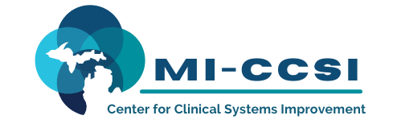

Michigan Center for Clinical Systems Improvement
233 E. Fulton Street, Suite 20
Grand Rapids, MI 49503

CERTIFICATE OF PARTICIPATION

This certifies that:
Enter Name of Participant

(Name of Participant)

Is awarded contact hours for the educational activity entitled:

Patient Centered Treatment for Substance Use Disorder (SUD) in Primary Care Series: Module #8 Operationalizing Team Meetings, Systematic Case Review, and Documentation
(Title of Activity)

Enter Date of Activity (Virtual) Grand Rapids, Michigan

(Date of Activity) (City/State of Activity)
This course, Supporting Patient-Centered Treatment of Substance Use Disorder, is approved by the NASW-Michigan Social Work Continuing Education Collaborative.
Course Approval Number: 120122-00
1.5 Contact Hours

The AAFP has reviewed Patient Centered Treatment For Substance Use Disorder in Primary Care, and deemed it acceptable for AAFP credit. Term of approval is from 10/24/2022 to 10/23/2023. Physicians should claim only the credit commensurate with the extent of their participation in the activity.

Participant is awarded up to 1.0 Credits

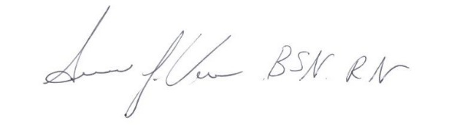
(To Be Completed by Participant) I participated in Enter # of credits Claimed credits of this CME activity.

Enter Participant Name 12/01/2022
Participant Name Signature of Planning Committee Activity Director Date

