Motivational Interviewing
Great Lakes ATTC
MI-CCSI

Fall 2020

Facilitator:
Laura A. Saunders, MSSW
Laura.saunders@wisc.edu

Motivational interviewing for
helping professionals

The materials in this packet are designed to provide you with the knowledge and skills you need to deliver MI with integrity to the model. Through reading, didactic lecture, videos, small and large group practice, and individual performance feedback you’ll be presented with opportunities to gain skill and confidence in the provision of this evidence- based practice.

GOAL: Systematically use MI in your work and move in the direction of fidelity to the practice.

Objectives

Be able to identify the key concepts of MI and how each relates to promoting positive behavior change.
- Be able to describe each process of MI (Engaging, Focusing, Evoking, Planning) and how each contributes to promoting positive behavior change.
- Apply MI skills for efficient and effective engagement (the Relational Foundation) and the elicitation of change talk (Technical skills).
- Begin integrating MI into your patient change conversations.
- Engage in an ongoing learning process to achieve fidelity.

Key Concepts in MI

- Resist the righting reflex
  - The “righting reflex” is the practitioner desire to fix what seems wrong with people and to set them promptly on a better course.
  - Expression of a directing communication style.
  - How do people who are ambivalent about change respond to the righting reflex?

Activity: Just Do it!
- What comments did you notice from peers who participated in this exercise?

- What kind of situations trigger your own righting reflex?

Communication style matters

Directing | Guiding | Following
Administer Authorize Conduct Decide Determine Lead Manage Prescribe Steer  Take charge Tell | Accompany Awaken Collaborate Elicit Encourage Inspire  Lay before Look after Motivate Show Support | Attend  Be responsive Be with  Go along with Have faith in Listen Observe Shadow  Stay with Take interest in  Understand

Activity: Communication Style Switching
Instructions: Watch the video and for each communication style, note 1-2 observations of what the practitioner said/did and how the client responded.
  - Following:

  - Directing:

  - Guiding:

Motivation is a key to change
  - Motivation is a state of being ready, willing, and able; it is not a trait.
  - Motivation is interpersonal; what the practitioner says and does matters.
  - Motivation is a key to successful change.

Activity: Self-Reflect on Motivation
Instructions: Think of a behavior you’ve engaged in even though you knew it might lead to negative consequences. Ideally, this would be a behavior you have made past attempts to change. With this behavior in mind, consider the following questions with brief written response.

- How much time passed between when you began this behavior and when you were first aware that there was a potential problem with it?

- How much time passed between the moment you first noticed there was a potential problem with this behavior and the first time you made an earnest attempt to change it?

- Did you ever experience success in changing this behavior?
Yes No

- Did you ever return to the behavior after initiating some change?
Yes _No

- How about the people in your life when you were attempting to change the behavior: Briefly describe (adjectives) how people were helpful.

- Briefly describe (adjectives) how people were not helpful.

Ambivalence about change is normal
  - Ambivalence means feeling two ways about something.
  - Presents a significant barrier to change.
  - Must be explored and (hopefully) resolved.

NO CHANGE
Pros | Cons
CHANGE
Cons | Pros

MI Processes (Miller & Rollnick, 2013, pp. 25-32)

Planning
Develop a specific goal and plan for change; build confidence.
Evoking
Explore motivation for change. Recognize, draw out, and respond to Change Talk.
Focusing
Come to agreement on the change target.
Engaging
The relational foundation. Establish then maintain a caring and productive working relationship with the client.

Miller, Moyers, Rollnick (2013) DVD. Your take-aways:

MI Core Skills (OARS)

Open questions
    - Affirmation
    - Reflective listening
    - Summarizing

Core skills are applied within each process in unique and creative ways.

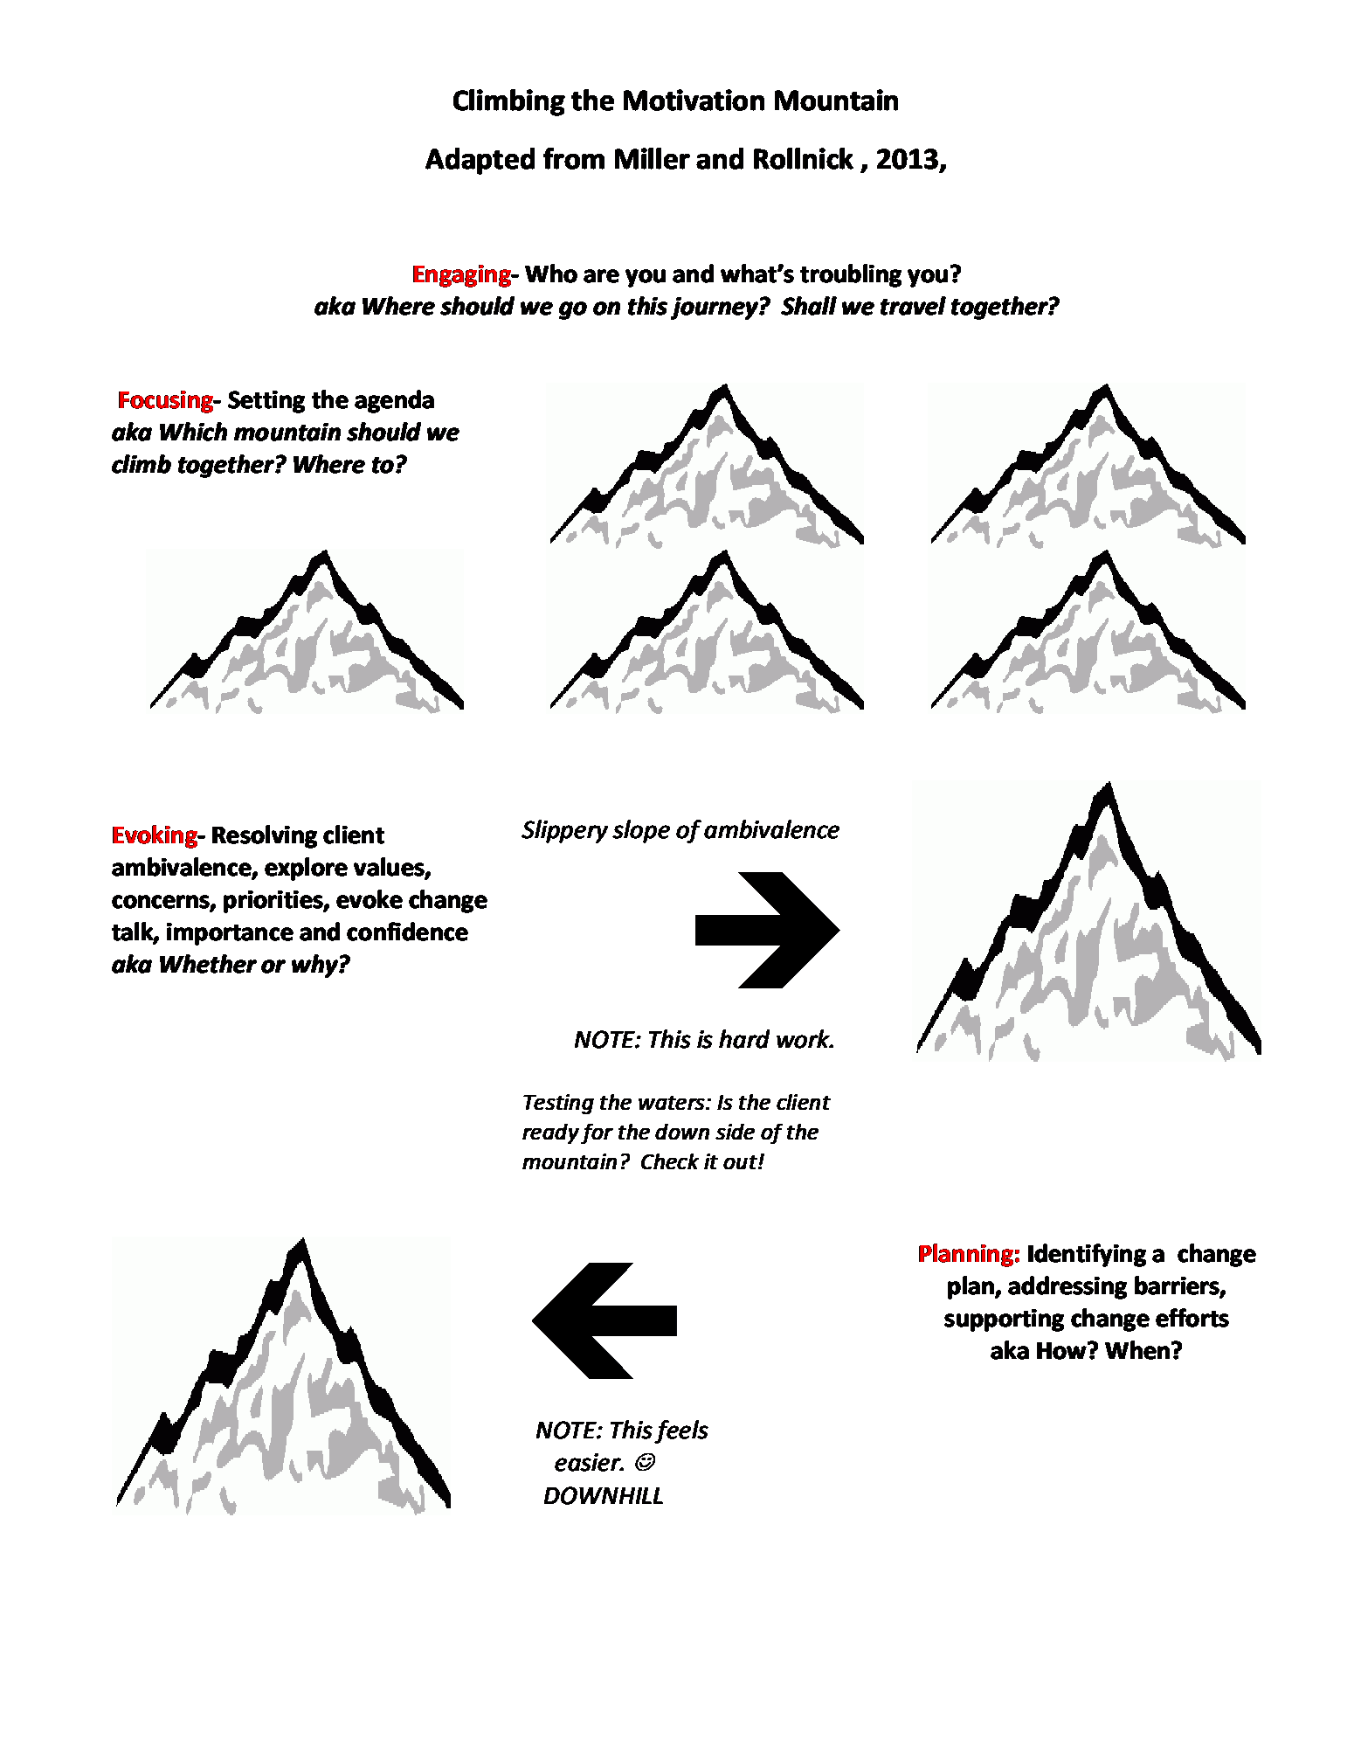

7

Engaging

The relational foundation. Establish then maintain a caring and productive working
relationship with the client.

Perspective Shifts
  - Engaging is Task #1 – the first 20% of every encounter.
  - Engaging in MI requires a way of being with people (the Spirit of MI).
  - Develop a partnership with shared expertise.
  - Rapid engagement is possible with MI skills.
  - Let go of assessment-oriented, fact gathering questions.
  - Competence vs. Deficit worldview – look for strengths.
  - Replace questions with reflections.

The Spirit of MI is a way of being with people which sets the PACE
of the conversation with these elements:

  - Partnership. MI is a collaboration between experts.
- People are the experts on their own lives.
- MI is not done “to” or “on” someone, but “for” and “with” a person.
- This includes both: Letting go of the expert role while being aware of the aspirations and convictions you bring to the conversation.

  - Acceptance. Expressing an attitude of unconditional positive regard.
- Absolute Worth.
- Accurate Empathy. o Autonomy Support. o Affirmation.

  - Compassion. We conduct MI in the service of others.
- Deliberate promotion of another’s welfare.
- Get ourselves out of the way.
- Serve as a benevolent witness.
- Distinguish this way of being with people from the tactics of a used car salesperson.

Engaging

The Spirit of MI (continued)
  - Evocation. Motivation for change is not installed but is evoked.
- Motivation for change already exists within people.
- Perspective that people truly have the wisdom and resources within themselves to identify and move towards their goals.
- Pragmatically, people are more likely to change if they themselves come up with the reasons versus being advised.

Discussion questions
- Which element(s) of MI spirit best fits with how you currently work?

- Which elements (s) might pose some challenge to how you currently work?

- Why might you be interested in bringing all MI spirit elements to the way you work?

MI Relational Foundation Measures (reproduced with permission from Moyers et al., 2015)

Partnership

1 (low) | 2 | 3 | 4 | 5 (high)
Clinician actively assumes the expert role for the majority of the interaction with the client. Collaboration or partnership is absent. | Clinician superficially responds to opportunities to collaborate. | Clinician incorporates client’s contributions but does so in a lukewarm or erratic fashion. | Clinician fosters collaboration and power sharing so that client’s contributions impact the session in ways that they otherwise would not. | Clinician actively fosters and encourages power sharing in the interaction in such a way that client’s contributions substantially influence the nature of the session.
Empathy

1 (low) | 2 | 3 | 4 | 5 (high)
Clinician gives little or no attention to the client’s perspective | Clinician makes sporadic efforts to explore the client’s perspective.  Clinician’s understanding may be inaccurate or may detract from the client’s true meaning. | Clinician is actively trying to understand the client’s perspective with modest success. | Clinician makes active and repeated efforts to understand the client’s point of view. Shows evidence of accurate understanding of the client’s worldview, although mostly limited | Clinician shows evidence of deep understanding of client’s point of view not just for what has been explicitly stated but what the client means but has not yet said.

Engaging

Core Skill: Open Questions
  - Promote engagement by exploring the person’s perspectives, experiences, and concerns.
  - The perspective shift here is to refrain from fact gathering/assessment questions (typically Closed Questions) at hello.
  - Use Open Question starters: What…? How…? Tell me about… Describe…

Activity: Questions at Hello
Instructions: Read each question and decide if it is Open or Closed and a Good ☺ or Not-so-Good ☹
engaging question. If Not-so-Good, construct a better engaging question.

Common Questions at hello | ☺ | ☹
1. What brings you here today?
2. Are you in a relationship?
3. Can we talk about paying your restitution?
4. How are you today?
5. Did you do what you were supposed to do?
6. Are you having a good day?

Now, using the starters above, construct 2-3 more engaging Open Questions:

Engaging

Core Skill: Affirmation
  - The perspective shift here is to actively look for, recognize, and affirm a person’s inherent worth, strengths, positive attributes, or past efforts with change.
  - Affirmation of strengths builds the relational foundation and promotes engagement.
  - Affirmations should not be confused with praise. Construct affirmation using a “you” statement.

We all need positive feedback. Affirmations promote partnership, self-efficacy, hope, and improved self-regard.
AFFIRMATIONS BUILD CONFIDENCE

Activity: Mining for Affirmations
- Start by brainstorming: What strengths do you observe in the people you work with? What are their positive personal attributes or resources? Write down a list of 15-20 strengths.

- Once the person you’re working with has identified some strengths, what affirmations can you offer in response to reinforce these positive self-perceptions?

Strengths & Values

Affirmation
Someone famous
Strengths/Values: Affirmation:

Engaging

Core Skill: Reflective listening
  - Accurate empathy or “reflective listening” is the most important skill in MI.
  - The perspective shift here is to replace questions with reflections.
  - Listen carefully to understand the person’s perspective.

Steps to forming a Reflection:
- Hear what the person is saying.

Barriers: Strategies:

- Make an educated guess about the person’s underlying meaning.
“You mean that you…”

- Choose your direction.

- Share your guess as a concise statement (not a question).

Engaging

Activity: Construct Simple and Complex Reflections.
“People I work with”= patients, clients, consumers, customers NOT co-workers.

I really like the work that I do. I feel like I am pretty good at what I do. I’ve helped a lot of people.
- Simple Reflection:

- Complex Reflection:

You know. There are some things I struggle with. I am not always 100% sure I am doing the best job I can with the people I work with.
- Simple Reflection:

- Complex Reflection:

Thinking about doing anything differently in my professional work life makes me uneasy. I am not sure I really have the time or the energy for that.
- Simple Reflection:

- Complex Reflection:

I really value having productive relationships with the people I work with. Some of this MI stuff makes sense and seems like it would make things a bit easier for me.
- Simple Reflection:

- Complex Reflection:

It’s really hard to constantly have the feeling that I am supposed to know all the answers and fix all the problems for the people I work with. I don’t always have what I need to run my own life because I put so much of myself into my work.

- Simple Reflection:

- Complex Reflection

Engaging

Core Skill: Summarizing
  - A summary is like a reflective listening paragraph and reflects back several things the person has shared. Summarizing can reinforce a person’s values, strengths, and motivations.
  - Three types:
    - Collecting summaries recall a series of items as they accumulate.
    - Linking summaries link the present conversation with something discussed before.
    - Transitional summaries bring it all together to wrap up a task, a process, or a session.
  - Start summaries with a “check-in” followed by a “checking it out” and end with an open question.

Activity: Create a Summary
Instructions: Based on the dialogue (previous page), create a collecting summary.

Engaging

Other Skills: MI Adherent (MIA) Behaviors
- Affirm: Recall than an affirmation accentuates a person’s inherent worth, strengths, positive attributes, or past efforts with change.
- Seek collaboration: The practitioner is explicitly attempting to share power or acknowledge the expertise of the client. Asking the client what they think about information or asking permission to give information.
- Emphasize autonomy: This code is assigned when the practitioner works to CLEARLY focuses the responsibility with the client highlighting their sense of control, freedom of choice, personal autonomy, or ability to decide about their own actions.

Activity: Making MIAs
Instructions: In the scenarios below, respond with MIAs.

Jim is a 34-year old man who has been living homeless for the last 5 years and has recently moved into a group home. Jim says, “I’ve been at this a long time, I know the deal. If you don’t go with the rules they kick you out. I know that. It’s either do the deal and stay in or don’t do the deal and get kicked out and be on my own.”

- Affirm:

- Seek:

- Emphasize:

Jacklyn is a 15-year old girl who’s been truant for most of her sophomore year. She’s been sick on and off and has some serious issues with anxiety. Jacklyn says, “I know I have to come to school. I don’t want to be like those girls I see just hanging out on the street nothing to do, looking bored. It’s just that I am bored here too. But I know I can’t be sitting at home, missing school much more.”

- Affirm:

- Seek:

- Emphasize:

Engaging

Traps that Promote Disengagement (Miller & Rollnick, 2013, pp. 40-45)

  - The “Chat” Trap
  - The Assessment (Question-Answer) Trap
  - The Expert Trap
  - The Premature Focus Trap
  - The Labeling Trap

Discord, not “Resistance”
When a client argues, interrupts, disagrees, ignores, or discounts you, this is viewed as discord in MI. “Discord is about you or more precisely about your relationship with the client… Discord is like a fire (or at least smoke) in the therapeutic relationship.”
(Miller & Rollnick, 2013, p. 197)

Activity: Self-Reflection on Client Discord
- What are statements and behaviors you’ve observed from clients that signal discord? Be specific.

- What is your reaction to these statements and behaviors?

- What part do you play in the dissonance? Specifically, what trap might you have fallen into?

- What would be some of the good things about changing the way you respond to dissonance? What’s the worst thing that could happen if you did nothing?

- Pick a statement of discord from above and write out an MI consistent response.

Technical definition of MI:

“Motivational Interviewing is a collaborative, goal-oriented style of communication with particular attention to the language of change. It is designed to strengthen personal motivation for and commitment to a specific goal by eliciting and exploring the person’s own reasons for change within an atmosphere of acceptance and compassion.” (Miller & Rollnick, 2013, p. 29)

MI Processes:
Planning
Develop a specific goal and plan for change; build confidence.
Evoking
Explore motivation for change. Recognize, draw out, and respond to Change Talk.
Focusing
Come to agreement on the change target,
Engaging
The relational foundation. Establish then maintain a productive working relationship with the client.

Technical Component

Skills:

- Core OARS Skills
- Informing (E-P-E), Seek Collaboration
- Emphasis on choice

Skills are applied within each process in unique and creative ways.

Focusing

Collaboratively come to agreement with the client on the change target. This could include: a specific behavior (engagement in services, medication adherence, parenting, completing school work, maintaining employment, high risk sexual behavior), substance (alcohol, illicit drug, tobacco),
or condition (depression, anxiety, grief).

Perspective Shifts
  - Focusing is a process with three possible scenarios
  - Balance client and practitioner priorities for change
  - Negotiation is often needed
  - Once the focus for change target(s) is agreed upon, stick with it until transition to next change target

Three Scenarios (Miller & Rollnick, 2013, pp. 99-101; Rosengren, 2018, pp. 174-175)

Clear Direction Agenda Mapping Orienting

Focus is clear. Client and practitioner are in agreement about the change target(s) for the session.
Focus is somewhat clear.
Some client and practitioner priorities are known, but negotiation is needed to come to agreement on focus of change target(s) for the session.
Focus is unclear.
Client and practitioner are not sure what the concerns or priorities are for the session.
Exploration is needed to determine change target(s).

Focusing

Balance Priorities

Core Skill: Informing (Miller & Rollnick, 2013, pp. 131-154; Rosengren, 2018, pp. 212)

First, find out about the person’s priorities or concerns.

  - Then, share your priority or concern using the E-P-E procedure:

    - Elicit client permission.
“Would it be okay if I shared a perspective with you?”

    - Provide the perspective on your priority or concern.

    - Elicit the person’s response.
“What are your thoughts on this?”

Listen carefully and Reflect.

Negotiate the agenda and come to agreement on the change target of focus
Focusing

Tool: Agenda Map
Instructions: Complete an agenda map thinking about the population you work with.

What might you like to talk about?

Once the change target is agreed upon, that becomes the focus of the change conversation until transition to the next one

Evoking

Once a change target is agreed upon and there is a clear, ethical direction for change transition to Evoking. Evoking explores the “why” of change. This process is the heart of MI during which the person’s ideas and motivations for change are explored.

Perspective Shifts
- Motivation is a key to change
- Let go of assessment/fact gathering questions
- Resist your righting reflex
- Maintain focus on the change target, avoid tangents
- Listen for the language of change

Your Tasks
- Recognize the language of change (Change Talk) and differentiate it from the language of no change (Sustain Talk) and Discord
- Proactively draw out Change Talk
- Strategically respond: cultivate change talk and soften sustain talk.

Begin climbing Motivation Mountain…

Evoking

Task #1: Recognize Language Cues
(Rosengren, 2018, pp. 269-275)

Change Talk is the language of change, that is, any client language in the direction of change regarding the change target. Types of Change Talk: DARN CAT

DESIRE: want, like, wish, hope to change ABILITY: can, could, able to change REASON: specific reason for change
NEED: need, have to, got to, must, it’s important to change
* * * *
COMMITMENT: I will, I’m going to, I intend to change ACTIVATION: ready to, willing, planning to change TAKING STEPS: specific action or step toward change

Sustain Talk is any client language in the direction of no change or the status quo; the opposite of Change Talk. Sustain Talk is about the change target.

Discord signals dissonance and is about the relationship.

So what? Why are these language cues important?
(Miller & Rollnick, 2013, pp. 167-171; Rosengren, 2018, pp. 267-268)

Evoking

Task #2: Proactively draw out Change Talk
(Rosengren, 2018, pp. 302-309)

The core skill here is Open questions. Instruction: Call forth the DARN CAT. For each category of change talk, develop 2-3 Open questions.

DESIRE (want, like, wish, hope):

ABILITY (can, could, able to):

REASON (specific reason for change):

NEED (need, have to, got to, must, it’s important to change):

* * * * * *
COMMITMENT (will, going to, intend to):

ACTIVATION (ready, willing, planning):

TAKING STEPS (specific step toward change recently taken):

Evoking

Task #2: Proactively draw out Change Talk (continued)

Querying Extremes
- What concerns you the most about in the long run?
- Suppose you continue on as you have been, without changing. What do you imagine are the worst things that could happen?
- From what you know, what might be some of the risks from continuing ?
- What do you think could be the best results if you did make this change?
- If you were completely successful in making the changes you want, how would things be different?
- Imagine for a minute that you succeeded in changing . What are some good things that might happen?

Looking Back
- Do you remember a time when things were going well for you? What has changed?
- What were things like before ? What were you like back then?
- How has changed you as a person or stopped you from growing, from moving forward?

Looking Forward
- If you did decide to make this change, what do you hope would be different in the future?
- How would you like things to turn out for you in [months/years] or so?
- If you were to have a week off from your symptoms/problems, what would you do first?
- How would you like things to be in the future?
- What do you expect might happen if you don't make any changes?

Exploring Goals and Values
- Tell me what you care most about in life. What matters most to you?
- How do you hope your life will be different a few years from now?
- How does making a change with _ fit with what you care most about, or your life goals or dreams?

Evoking

Task #2: Proactively draw out Change Talk (continued)
What is the problem?
(Miller & Rollnick, 2013, p. 213)

 |  | Importance to change
 |  | Low | High
Confidence to change | Low | 1 | 2
 | High | 3 | 4

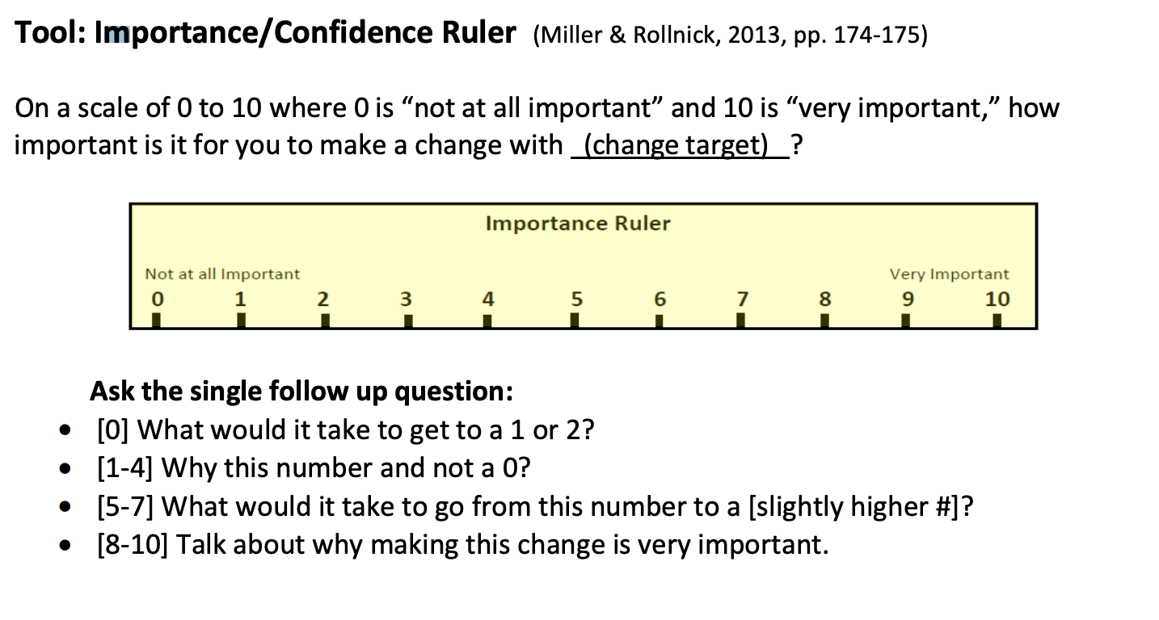

Evoking

Task #3: Strategically Respond Cultivate Change Talk

When you hear Change Talk, don’t just sit there! (Miller & Rollnick, 2013, pp. 183-188)

Use your OARS:

Open question to ask for elaboration
Client: I need to cut down on the drinking. Practitioner: Tell me more.

Affirm an underlying strength
Client: I’m going to take a break for a few weeks. Practitioner: You have a lot of will-power.

Reflect
  - Simple Reflection to highlight the specific language cues
  - Complex Reflection to offer a guess in the direction of change

- Summarize – collect the Change Talk flowers
and offer back as a bouquet

Best practice:
- Start by briefly acknowledging any Sustain Talk/reasons for no change.
- Then, highlight Change Talk, motivations, and reasons for change.
- End with a question that moves the conversation forward.

2
Reflection
3
Reflection
1
Ask for elaboration (Tell me more…)
4
Summarize
Speaker
starts
Evoking

Activity: Cultivating Change Talk is Easy as 1-2-3-4

Moving from practice-as-usual to delivering MI with fidelity requires your own behavior change. With this change in mind, please note your response in the space provided below to one of the following questions:

- Why would you want to integrate MI into your services?
- What is one skill you could work on to develop your MI practice?
- What would be the best reason to get MI into routine practice with your clients?
- What would you need to do differently in order to deliver MI with fidelity? Your response:

  - Speaker starts by sharing the above written statement.
  - Moving to the speaker’s left, group members do 1-2-3-4 in turn.
  - Speaker responds naturally to each group member.

Evoking

Evoking Task #3: Strategically Respond Cultivate Change Talk

Instructions: Read the client narrative below, then work together as a group to create MI consistent responses.
Client: I have to do something about my drinking. I know it’s really bad for me and I can’t keep this up. I am going to lose everything.
- Open question: (shift focus or reframe)

- Affirmation: (find an underlying strength)

- Reflection: (construct two concise reflections using strategic complex types) a)

b)

Soften Sustain Talk/Discord
(Miller & Rollnick, 2013, pp. 200-210; Rosengren, 2018, pp. 360-364, 374)

Instructions: Read the client narrative below, then work together as a group to create MI consistent responses.
Client: I already told you I don’t have a problem with drinking and so what if I smoke some weed? Everyone I know smokes. Why do you care what I do? I’ve been to treatment before so I know all about the risks. There’s nothing you can tell me that I don’t already know.
- Open question: (shift focus or reframe)

- Affirmation: (find an underlying strength)

- Reflection: (construct two concise reflections using strategic complex types) a)

b)

- Emphasize choice/personal control:

Evoking

Activity: Rowing with OARS for Evoking

Roles:

Speaker – real play. Consider talking about continuing to learn MI: What changes will you need to make to get MI into routine practice? What will you need to work on to reach fidelity?
  - Practitioner – go right into Evoking. Use your OARS to explore the Speaker’s motivation for change.
  - Observer – listen carefully to the Practitioner and use the observer sheet provided to note skills.

Debrief:

Practitioner starts by sharing what she/he liked about the interview and what could have been different, then

  - Observer shares feedback using Elicit-Provide-El
MI References

- Miller, W. R., & Rollnick, S. (2013). Motivational interviewing: Helping people change (3rd edition). New York, NY: Guilford Press.

- Miller, W. R., Moyers, T. B., & Rollnick, S. (2013). Motivational interviewing: Helping people change [training DVD]. From https://www.changecompanies.net/products/motivational- interviewing/

- Moyers, T. B., Manuel, J. K., & Ernst, D. (2015). Motivational Interviewing Treatment Integrity coding manual 4.2.1. Unpublished manual, University of New Mexico, Center on Alcoholism, Substance Abuse, and Addiction. Retrieved from https://casaa.unm.edu/download/MITI4_2.pdf

- Rosengren, D. (2018). Building motivational interviewing skills: A practitioner workbook (2nd edition). New York, NY: Guilford Press.

Closing Review

Something I learned or relearned…

- From this course I gained…

- One thing I learned about myself as a practitioner…

- I am more confident now that I can…

- I’m going to integrate MI into practice by…

Suppo

