Michigan Center for Clinical Systems Improvement
233 E. Fulton Street, Suite 20
Grand Rapids, MI 49503

CERTIFICATE OF PARTICIPATION

This certifies that:
Click to Enter Name of Participant

(Name of Participant)

has participated in the educational activity entitled:

Brief Interventions for Depression Management
(Title of CME Activity)

Click to Enter the Date of the Activity (Virtual) Grand Rapids, Michigan

(Date of Activity) (City/State of Activity)

and is awarded up to 1.5 credits.

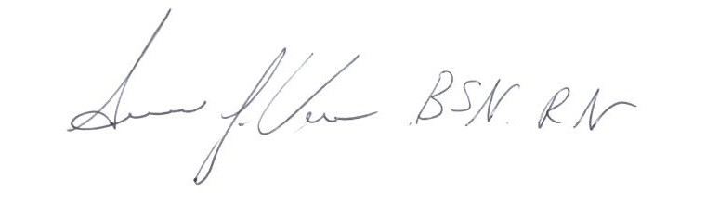
The AAFP has reviewed Brief Interventions for Depression Management, and deemed it acceptable for AAFP credit. Term of approval is from 10/25/2022 to 10/24/2023. Physicians should claim only the credit commensurate with the extent of their participation in the activity.

Participant’s Attestation:
- I participated in <Click or tap to enter # of credits claimed> credits of the CME activity.
Susan Vos, RN, BSN, CCM
- <Click or tap to enter text or signature & date> Activity Director-Mi-CCSI
Participant’s Signature & Signature Date
10/25/2022 Date

