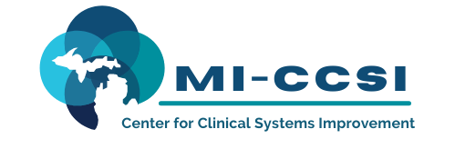

Michigan Center for Clinical Systems Improvement
233 E. Fulton Street, Suite 20
Grand Rapids, MI 49503

CERTIFICATE OF PARTICIPATION

This certifies that:
Enter Name of Participant

(Name of Participant)

Is awarded contact hours for the educational activity entitled:

Problem Solving Treatment
(Title of Activity)

November 1, 2022 (Virtual) Grand Rapids, Michigan
This course, Problem Solving Treatment, is approved by the NASW-Michigan Social Work Continuing Education Collaborative.
Course Approval Number: 120621-02
1.5 Contact Hours

(Date of Activity) (City/State of Activity)

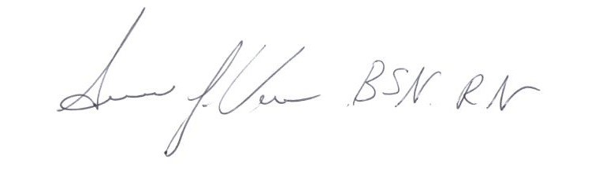

_____________________________________
Signature of Planning Committee Activity Director

