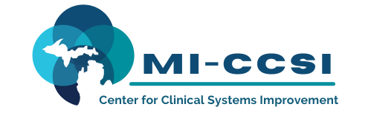

Michigan Center for Clinical Systems Improvement
233 E. Fulton Street, Suite 20
Grand Rapids, MI 49503

CERTIFICATE OF PARTICIPATION

This certifies that:
Enter Name of Participant

(Name of Participant)

Is awarded contact hours for the educational activity entitled:

Behavioral Activation
(Title of Activity)

November 16, 2022 (Virtual) Grand Rapids, Michigan
This course, Behavioral Activation, is approved by the NASW-Michigan Social Work Continuing Education Collaborative.
Course Approval Number: 110221-01
1.0 Contact Hours

(Date of Activity) (City/State of Activity)

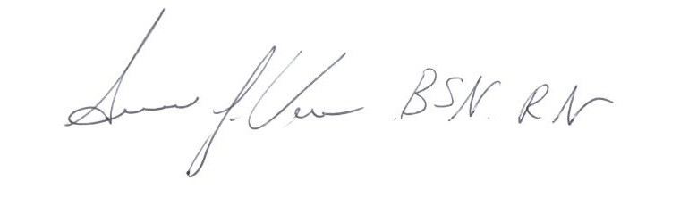

_____________________________________
Signature of Planning Committee Activity Director

