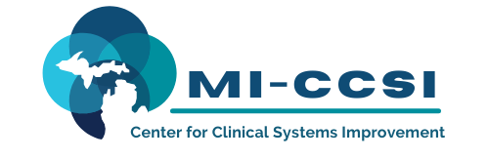

Michigan Center for Clinical Systems Improvement
233 E. Fulton Street, Suite 20
Grand Rapids, MI 49503

CERTIFICATE OF PARTICIPATION

This certifies that:
Enter Name of Participant

(Name of Participant)

Is awarded contact hours for the educational activity entitled:

Motivational Interviewing SBIRT & Putting it All Together
(Title of Activity)

July 26, 2022 (Virtual) Grand Rapids, Michigan
This course, Motivation Interviewing, is approved by the NASW-Michigan Social Work Continuing Education Collaborative.
Course Approval Number: 010722-01
1.5 Contact Hours

(Date of Activity) (City/State of Activity)

This nursing continuing professional development activity was approved by the Ohio Nurses Association, an accredited approver by the American Nurses Credentialing Center’s Commission on Accreditation (OBN-001-91)
ONA Course Approval Number: 2020-0000000815
1.0 Contact Hours

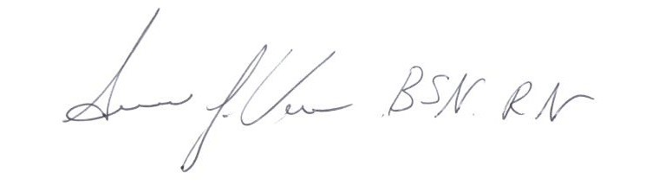

_____________________________________
Signature of Planning Committee Activity Director

