Michigan Center for Clinical Systems Improvement
233 E. Fulton Street, Suite 20
Grand Rapids, MI 49503

CERTIFICATE OF PARTICIPATION

This certifies that:
Enter Name of Participant

(Name of Participant)

Is awarded contact hours for the educational activity entitled:

Introduction to Team-Based Care
(Title of Activity)

Enter Date Completed (Virtual) Grand Rapids, Michigan
This course is approved by the NASW-Michigan Social Work Continuing Education Collaborative.
Course Approval Number: 080921-00
7.0 Contact Hours

(Date of Activity) (City/State of Activity)

This nursing continuing professional development activity was approved by the Ohio Nurses Association, an accredited approver by the American Nurses Credentialing Center’s Commission on Accreditation (OBN-001-91)
ONA Course Approval Number: 2022-0000000334
7.5 Contact Hours

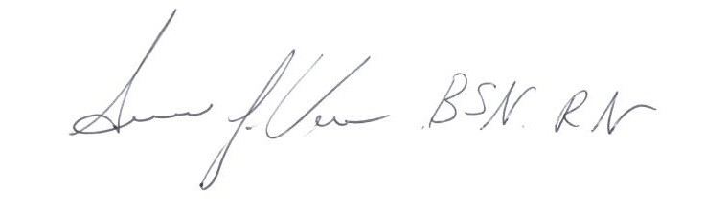

_____________________________________
Signature of Planning Committee Activity Director

