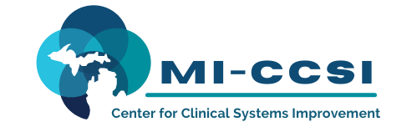

Michigan Center for Clinical Systems Improvement
233 E. Fulton Street, Suite 20
Grand Rapids, MI 49503

CERTIFICATE OF PARTICIPATION

This certifies that:
<Enter Name of Participant>

(Name of Participant)

Is awarded contact hours for the educational activity entitled:

Treating Pain and Addiction-Aspects of Pain Management
(Title of Activity)

June 3, 2022 (Virtual) Grand Rapids, Michigan

(Date of Activity) (City/State of Activity)

This course is approved by the NASW-Michigan Social Work Continuing Education Collaborative
Course Approval Number: 110121-03
3.5 Contact Hours
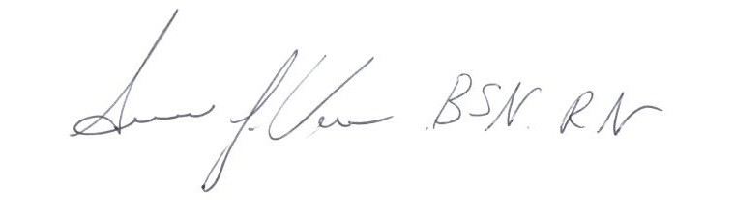

_____________________________________ Signature of Planning Committee Activity Director

