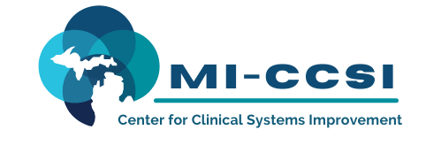
Michigan Center for Clinical Systems Improvement
233 E. Fulton Street, Suite 20
Grand Rapids, Michigan 49503

Issues this CERTIFICATE OF PARTICIPATION to:

Is awarded contact hours based on the applicable approval body as listed below:

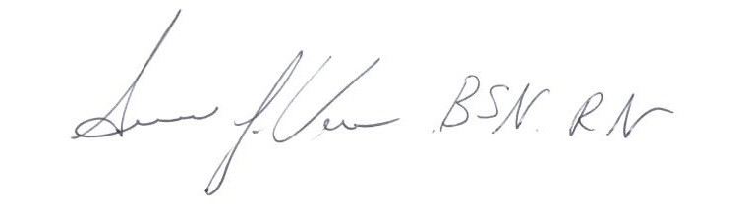
Engagement: Optimizing Self-Management Through Improved Patient Engagement ________________________
(Date of Activity)

______________________________
Susan Vos RN, BSN, CCM
Planning Committee – Mi-CCSI

This nursing continuing professional development activity was approved by the Ohio Nurses Association, an accredited approver by the American Nurses Credentialing Center’s Commission on Accreditation (OBN-001-91)
__________________________________________________________________________________________________
Approval ONA#: 2022-0000000186
__________________________________________________________________________________________________
6.5 Contact Hours

This course is approved by the NASW-Michigan Social Work Continuing Education Collaborative
Course Approval Number: 081021-00
6.5 Contact Hours

