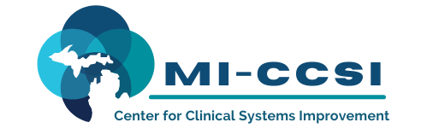

Michigan Center for Clinical Systems Improvement
233 E. Fulton Street, Suite 20
Grand Rapids, MI 49503

CERTIFICATE OF PARTICIPATION

This certifies that:
Click to Enter Name of Participant

(Name of Participant)

has participated in the educational activity entitled:

Treating Pain and Addiction-Aspects of Pain Management
(Title of CME Activity)

April 22, 2022 (Virtual) Grand Rapids, Michigan

(Date of Activity) (City/State of Activity)

and is awarded up to 3.5 credits.

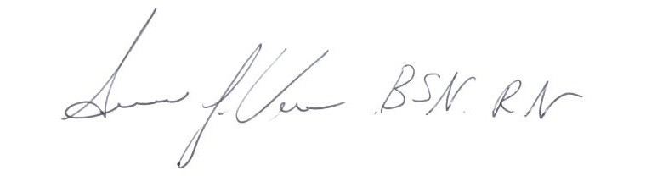
This live activity, Treating Pain and Addiction, from 12/01/2021 - 11/30/2022, has been reviewed and is acceptable for up to 3.5 Prescribed credit(s) by the American Academy of Family Physicians. Providers should claim only the credit commensurate with the extent of their participation in the activity.

Participant’s Attestation:
- I participated in <Click or tap to enter # of credits claimed> credits of the CME activity.
Susan Vos, RN, BSN, CCM
- <Click or tap to enter text or signature & date> Activity Director-Mi-CCSI
Participant’s Signature & Signature Date
04/22/2022 Date

