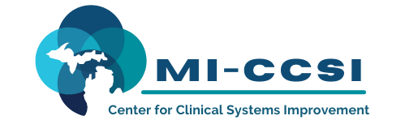

Michigan Center for Clinical Systems Improvement
233 E. Fulton Street, Suite 20
Grand Rapids, MI 49503

CERTIFICATE OF PARTICIPATION

This certifies that:
Enter Name of Participant

(Name of Participant)

has participated in the educational activity entitled:

SUD Learning Collaborative Series:
Prescribing Challenges and Experiences with Tapering
(Title of CME Activity)

June 24, 2022 (Virtual) Grand Rapids, Michigan

(Date of Activity) (City/State of Activity)

and is awarded up to 1.5 credits.

The AAFP has reviewed SUD Learning Collaborative Series, and deemed it acceptable for AAFP credit. Term of approval is from 12/10/2021 to 12/09/2022. Physicians should claim only the credit commensurate with the extent of their participation in the activity.

To Be Completed by Participant:

I participated in Enter # of credits Claimed credits of this CME activity.
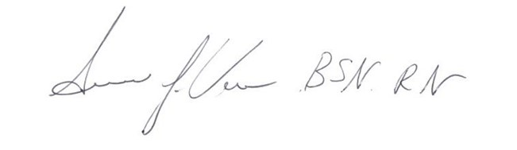 06/24/2022
Signature of CME Activity Director Date

Enter Name of Participant 06/24/2022

Participant Name Date

