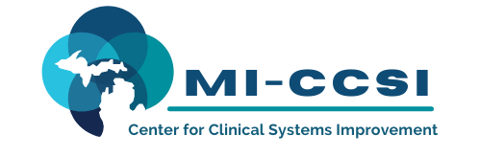

Michigan Center for Clinical Systems Improvement
233 E. Fulton Street, Suite 20
Grand Rapids, MI 49503

CERTIFICATE OF PARTICIPATION

This certifies that:
Enter Name of Participant

(Name of Participant)

has participated in the educational activity entitled:

SUD Learning Collaborative Series:
SBIRT Technical Support Follow Through (BIRT)
(Title of CME Activity)

February 18, 2022 (Virtual) Grand Rapids, Michigan

(Date of Activity) (City/State of Activity)

and is awarded up to 1 credits.

The AAFP has reviewed SUD Learning Collaborative Series, and deemed it acceptable for AAFP credit. Term of approval is from 12/10/2021 to 12/09/2022. Physicians should claim only the credit commensurate with the extent of their participation in the activity.

To Be Completed by Participant:

I participated in Enter # of credits Claimed credits of this CME activity.
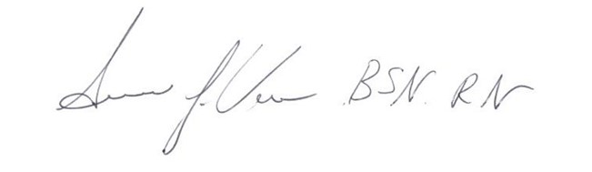 02/18/2022
Signature of CME Activity Director Date

Enter Name of Participant 02/18/2022

Participant Name Date

