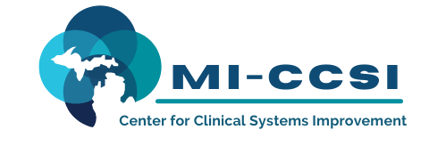

Michigan Center for Clinical Systems Improvement
233 E. Fulton Street, Suite 20
Grand Rapids, MI 49503

CERTIFICATE OF PARTICIPATION

This certifies that:
Enter Name of Participant

(Name of Participant)

has participated in the educational activity entitled:

Treating Pain and Addiction-Aspects of Pain Management
(Title of CME Activity)

December 3, 2021 (Virtual) Grand Rapids, Michigan

(Date of Activity) (City/State of Activity)

and is awarded up to 3.5 credits.

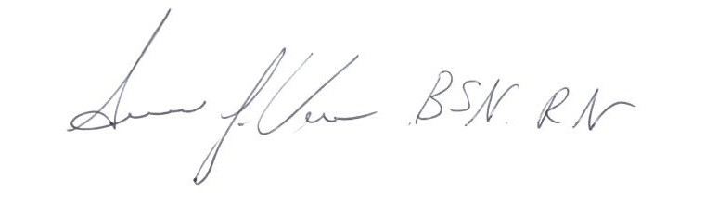
This Live activity, Treating Pain and Addiction, from 12/01/2021 - 11/30/2022, has been reviewed and is acceptable for up to 3.5 Prescribed credit(s) by the American Academy of Family Physicians. Providers should claim only the credit commensurate with the extent of their participation in the activity.

To Be Completed by Participant:

I participated in Enter # of credits Claimed credits of this CME activity.
_____________________________________ ____________________________ _____________ Signature of CME Activity Director
Participant’s Signature Date 12/03/2021

