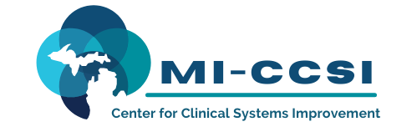
Michigan Center for Clinical Systems Improvement
233 E. Fulton Street, Suite 20
Grand Rapids, Michigan 49503

CERTIFICATE OF PARTICIPATION

This certifies that:
Enter Attendee Name
______________________________________________________
(Name of Participant)

has participated in the educational activity entitled:

BHCM Collaborative Care

Enter Training Date
(Date of Activity)

and is awarded 4.5 contact hours.
This course is approved by the NASW-Michigan Social Work Continuing Education Collaborative
Course Approval Number: 102721-00
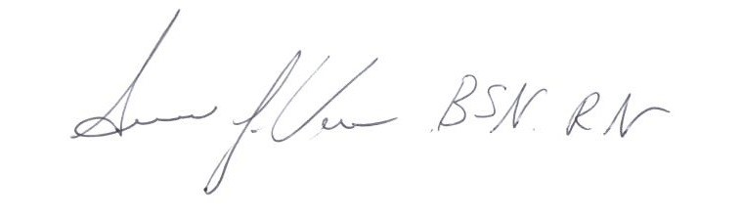

Susan Vos, RN, BSN, CCM
Activity Director-Mi-CCSI
11/04/2021 Date

