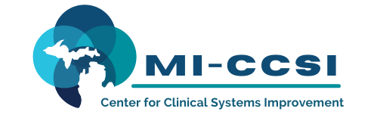

(Attendee)

HAS COMPLETED:

Team-Based Care Training:

Optimizing Care Delivery Impact Through The Team-Based Care Approach

on:

(Training Date)

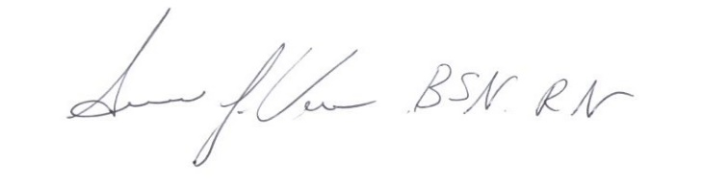

Location:

Virtual Live Training

233 E. Fulton St. Suite 20 Program Director

Grand Rapids, MI 49503

