Michigan Center for Clinical Systems Improvement
233 E. Fulton Street, Suite 20
Grand Rapids, Michigan 49503

CERTIFICATE OF PARTICIPATION

This certifies that:

Enter Your Name

(Name of Participant)

has participated in the educational activity entitled:

Team-Based Care

Enter Date of Training (Virtual) Grand Rapids, Michigan
(Date of Activity) (City/State of Activity)

and is awarded up to 7.50 credits.

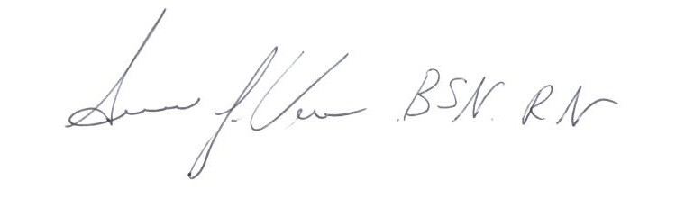
The AAFP has reviewed Team Based Care, and deemed it acceptable for AAFP credit. Term of approval is from 10/23/2021 to 10/22/2022. Physicians should claim only the credit commensurate with the extent of their participation in the activity.

I participated in Enter # of Credits Claimed credits of this CME activity.
Susan Vos RN, BSN, CCM
____________________________ Enter Date Activity Director – MiCCSI
Participant’s Signature Date
10/23/2021
Date

