(Attendee)

HAS COMPLETED:

Engagement Training: Optimizing Self-Management Through Improved Patient Engagement

on:

(Training Date)

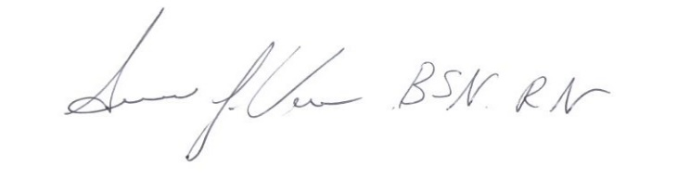

Location:

Virtual Live Training

233 E. Fulton St. Suite 20 Program Director

Grand Rapids, MI 49503

