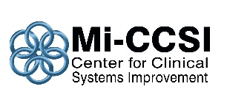

Michigan Center for Clinical Systems Improvement
233 E. Fulton Street, Suite 20
Grand Rapids, Michigan 49503

Issues this CERTIFICATE OF ATTENDANCE to:

Is awarded contact hours based on the applicable approval body as listed below

Behavioral Activation Webinar
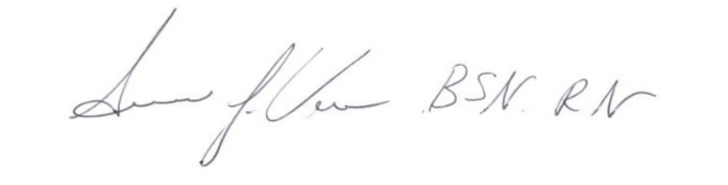
Date: _________________

_________________________________
Susan Vos RN, BSN, CCM
Planning Committee Mi-CCSI

This nursing continuing professional development activity was approved by the Ohio Nurses Association, an accredited approver by the American Nurses Credentialing Center’s Commission on Accreditation (OBN-001-91)
Approval ONA#: 2020-0000000815
1.0 Contact Hours

This course is approved by the Michigan Social Work Continuing Education Collaborative
Course Approval Number: 102220-01
1.0 Contact Hours

