Michigan Center for Clinical Systems Improvement
233 E. Fulton Street, Suite 20
Grand Rapids, Michigan 49503

Issues this CERTIFICATE OF PARTICIPATION
to:
Enter Name

Is awarded contact hours based on the applicable approval body as listed below:

Introduction to Team Based Care

Enter Date of Training
(Date of Activity)
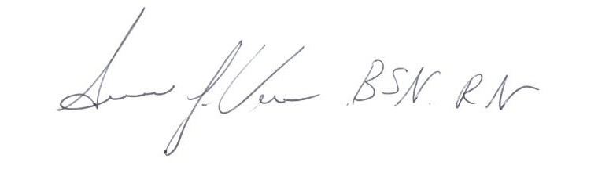

______________________________
Susan Vos RN, BSN, CCM
Planning Committee – Mi-CCSI

This course is approved by the NASW-Michigan Social Work Continuing Education Collaborative
Course Approval Number: 080921-00
7 Contact Hours

