TREATING PAIN & ADDICTION
Part One – February 16th, 2021
EVENT SCHEDULE
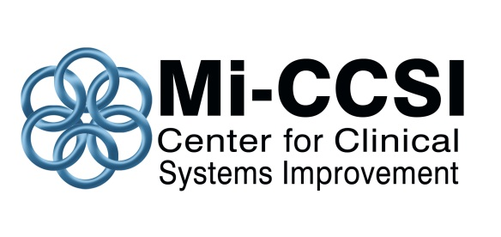

7:30-8:00 AM | Zoom open & registration confirmation (virtual sign-in)
8:00-8:10 AM | Welcome & introductions
8:10-8:55 AM | Biomedical aspects of pain management  DANIEL CLAUW, MD | Describe the variable clinical presentations of chronic pain.
8:55-9:45 AM | Biopsychosocial aspects of pain management  DAVID WILLIAMS, PhD | Describe evidence-based therapies for the treatment of chronic pain.
9:45-10:00 AM | BREAK (15 minutes)
10:00-10:45 AM | Medication management for chronic pain: the pharmacist’s perspective.  CLAIRE NOLAN, PharmD | Describe opportunities to optimize the expertise of the pharmacist as a member of the care team.
10:45-11:30 AM | Cannabinoids for pain management  DANIEL CLAUW, MD | Explain mechanisms of action and risks associated with cannabinoids.
11:30 AM-12:15 PM | Differentiating between Chronic Pain & Substance Use Disorder  EVA QUIRION, FNP, PhD | Explain the different mechanisms of action of chronic pain and SUD.
12:15- 12:25 PM | Wrap-Up and Evaluations

Part Two of this training event is scheduled for Friday, February 26, 2021 beginning at 7:30 AM. During this second session, workshops focused on (1) Substance Use Disorder and (2) Team-Based Care will occur simultaneously. Additional details to follow.

This training is made available via a grant from the Michigan Department of Health and Human Services (MDHHS) and Centers for Disease Control and Prevention (CDC).

